=========================================================
SQL PRACTICE NOTES - ORDERS TABLE
=========================================================

STEP 1: CREATE TABLE
---------------------------------------------------------
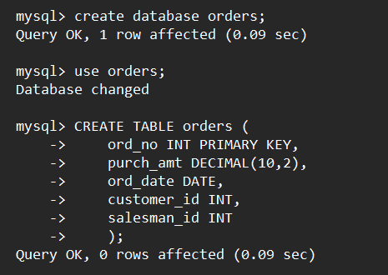

=========================================================
STEP 2: INSERT DATA
=========================================================
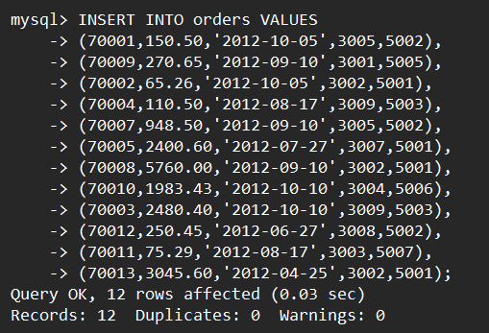

=========================================================
QUESTION 1 - WHERE CLAUSE
=========================================================
SCENARIO:
Finance wants all orders whose purchase amount is greater
than $2,000.

QUERY:
SELECT *
FROM orders
WHERE purch_amt > 2000;

OUTPUT:
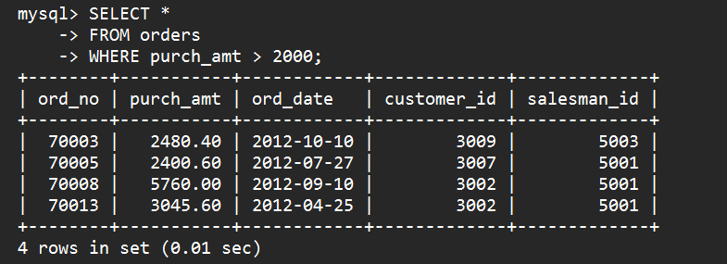

=========================================================
QUESTION 2 - WHERE CLAUSE
=========================================================
SCENARIO:
Management wants all orders placed on 2012-09-10.

QUERY:
SELECT *
FROM orders
WHERE ord_date='2012-09-10';

OUTPUT:
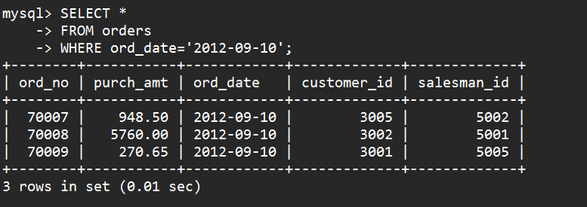

=========================================================
QUESTION 3 - WHERE CLAUSE
=========================================================
SCENARIO:
Find all orders handled by salesman 5001.

QUERY:
SELECT *
FROM orders
WHERE salesman_id=5001;

OUTPUT:
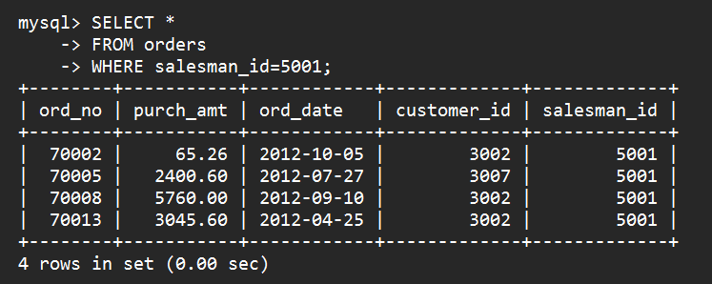

=========================================================
QUESTION 4 - ORDER BY
=========================================================
SCENARIO:
CEO wants to see orders ranked from highest amount to
lowest amount.

QUERY:
SELECT *
FROM orders
ORDER BY purch_amt DESC;

OUTPUT:
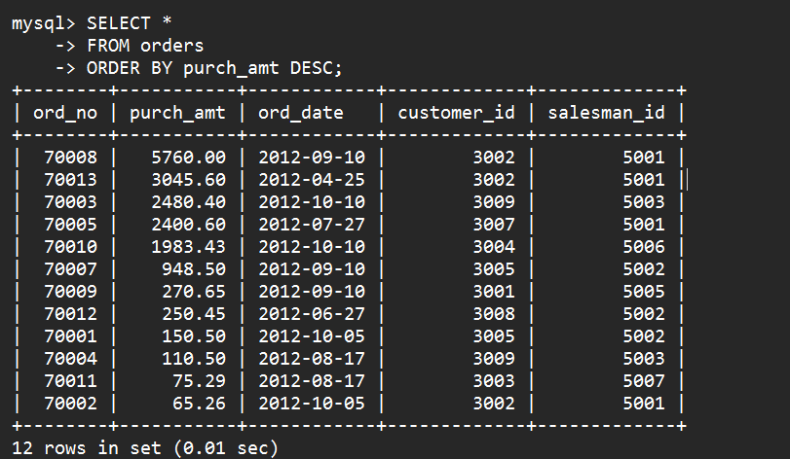

=========================================================
QUESTION 5 - ORDER BY
=========================================================
SCENARIO:
Operations team wants oldest orders first.

QUERY:
SELECT *
FROM orders
ORDER BY ord_date;

OUTPUT:
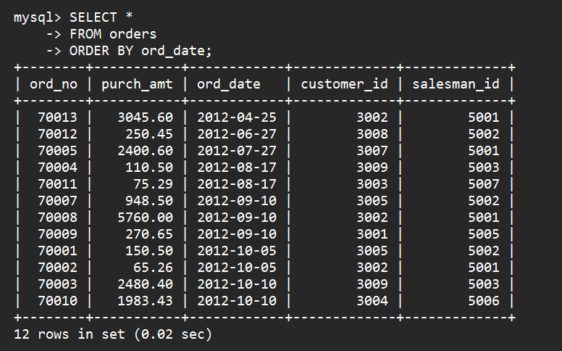

=========================================================
QUESTION 6 - SUM()
=========================================================
SCENARIO:
Finance department wants total revenue generated.

QUERY:
SELECT SUM(purch_amt) AS total_revenue
FROM orders;

OUTPUT:
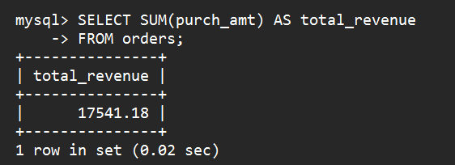

=========================================================
QUESTION 7 - AVG()
=========================================================
SCENARIO:
Management wants average order value.

QUERY:
SELECT AVG(purch_amt) AS average_order
FROM orders;

OUTPUT:
